Day 1 – 2 Aug 2024

Q?

In Core Python : No Question on Core Python

**Web Application**

<http://www.google.com> -🡪 url

req(http/https)-----🡪

Client Server

🡨-------Res(http/https) html or html5

Css or css3

Bootstrap

JS : JavaScript

Spring boot (Java)

.net (Asp.net)

Django Framework

Node JS(Express JS)

Php

Html : hyper text markup language which help to create web pages. Html provided lot of pre defined tags with help of those tags we can create more than one web page.

Css : cascading style sheet : which provided set of property-value which help to apply styling for web pages.

JavaScript help to do validation on client side machine.

Micro service

Rest full web service

Django framework it is a framework Like JANG-go with D is silent. Django is framework.

Framework : Framework provided set of API(application programming interface) ie can be function or classes or interfaces. Which internally communicate with each others to perform particular task. If we develop any application using framework 70 to 80% work taken care by framework. But framework it not final product it is protocol or template.

Design pattern best practise or solution for repeating problem statements. Implementation of design pattern taken care by framework.

Django is an open source framework. Using this framework lot organization develop application like Instagram, You tube, Dropbox etc.

Pre configured modules in Django framework

1. URL routing provided. <http://localhost:portnumber/path>
2. They provide dynamic template pages using html and css.
3. Database configuration by default it provide SQLite
4. Web security : Authentication and Authorization

Django internally base MTV Design pattern.

Model Template View

Model : model is responsible to deal with database. It is use to store, retrieve, delete and update data.

Template : using html responsible to display data on browser like using tag like p, div, span or table or list etc.

View :The view describe the data to be presented and passes this information to the template(dynamic html page).

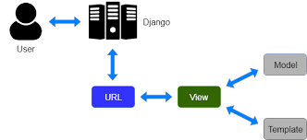

Using pip please install below module

sudo pip install virtualenv

virtualenv venv -p python

using ls command please verify folder name created or not.

source venv/bin/activate

after activated virtual environment we need to install django

pip install django

using pip list we can verify installed module in current virtual environment.

To create Django project we need to use pre defined command as

django-admin

please verify command working or not.

Now we create the project

django-admin startproject projectname

cd projectname

to run the project we need to use below url

python manage.py runserver

Django internally provided few predefined models for admin task.

So we need to run few command to enable admin task.

python manage.py makemigrations

it create file which is responsible to create the table on database. This file ready on Django framework side.

python manage.py migrate

when we do the migrate changes base upon model effected on default database ie SQLite

creating admin account

python manage.py createsuperuser

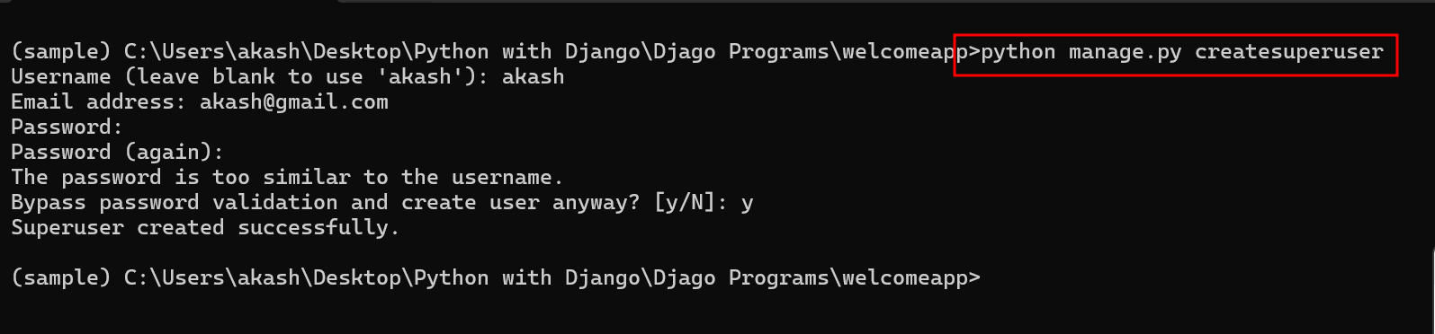

Django allow use to create app or module which is responsible to do specific task like employee app, customer app, login app, account app etc.

To create user defined app or module we need to run the command as

python manage.py startapp appname

python manage.py startapp first_app

after created user defined app or module we need to provide this module or app details in main project inside setting.py file in installed_app section

